

**Are we Java or are we Scripters?**

Welcome to day 2 of JavaScript!

Yesterday we went over some of the basics of coding. We talked about variables, functions, arrays, and the different data types. This sheet is meant to help us review and solidify that information.

My students were struggling with code to the point of talking to their parents and eventually client services….I responded to this by making a review sheet that combined different ways of recalling information. If you ever take or have taken a Psychology 101 class they talk about levels of comprehension and how to help yourself study. I applied what I learned there. I start off with simple matching, then I created a word bank for them to fill in the code given to me on game plan. I had them label and try to really dig into reading code. Reading code is a great way to get kids away from the computer and to make sure they are interacting with the material not simply staring blankly. Lastly I made them recall the information on their own, but made sure I dropped subtle hints. There are a few code typos because I did this kind of late at night...I used those as teachable moments showing that even Ace makes mistakes, and helped them debug some errors. I decided to keep them in.

Match the declared Variable with the Data Type.

var x =5; String

var x=”Cheesy Bacon”; Number

Undefined

var x; Array

var heroes[“Batman”,”Steve”,”Thomas the Tank Engine”,”Master Chief ”];

After you complete that congratulate yourself. Here is a picture of some cheesy bacon fries, and a baby bat who thinks he/she is batman.

A little added humor never hurt anyone.

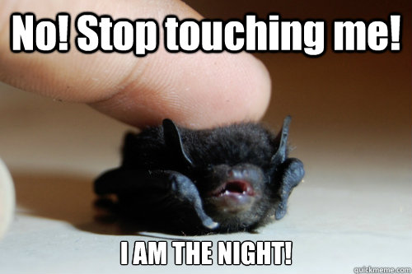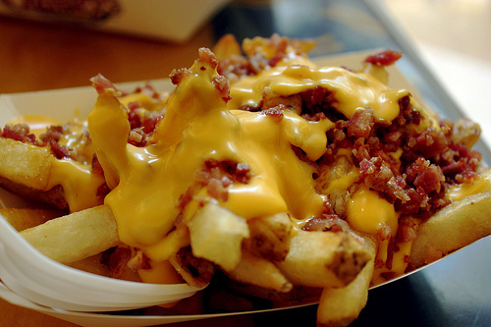

Label each picture based on if it is an angry baby bat or a picture of cheesy bacon covered fries.

MMMMMM I bet you are hungry now for some more JAVASCRIPT.

Wow you dominated that last one! You are a bat/cheesy bacon fries detective.

Below we have our Challenge CODE for variables. I want to make sure we understand each part of the code so let's label it with the SUPER AWESOME WORD BANK OF POWER!!!!!!!

After Each Line I will have a RED BLANK make sure you place the appropriate word there. Word can be used more than once but do not have to be!

//the blanks below will be **labels** not actual **code** but **still from the word bank!**

<!DOCTYPE html> ____________________________________

<html lang="en">

<head> ________________________

<script>___________________________________________

//Variables storing player information.

_________________________________________________

//The blanks below will be **code snippets** **from the word bank**

________________________________________

________________________________________

________________________________________

______________________________________

if (_______>0)

{

//Console logs display player information.

//Enter variable names without quotes.

console.log("Player's name: " + _______________________________);

console.log("Player's health: " + _____________________________);

console.log("Player's damage dealt: " __________________________);

}

else

{

console.log(“oooops our hero ” +_________+” has failed his goal of

completing ”+ _______________ + “ Because your health has reached below 0“. ;

}

// hint think what you want to be printed to the console. You have to use the word bank so you cannot just write what you want the else or if statements to say. You must use variables!

// Blanks below will be **LABELS from the word bank**

</script>_____________________________

</head>_________________________________________

<body>___________________________________

</body>____________________________________

</html>_________________________________________

WORD BANK IS ON THE NEXT PAGE! GO MAKE A WITHDRAWAL!

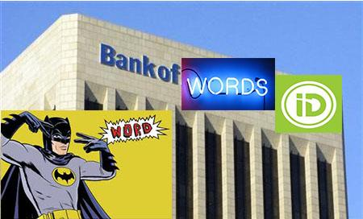\

WOW THAT IS AN AMAZING PICTURE OF A BANK! WHERE DID YOU FIND THAT!???

Open HTML Tag Open Head Tag

Closed HTML Tag Closed Head Tag

Open Script Tag var name=”baby bat master of all bacon”;

Closed Script Tag var health=100;

Open Body Tag var attack=25;

Closed Body Tag var quest=”the quest for the magical bacon fries of immortality ”;

Above and Below this are JavaScript Comments.

name

health

attack

quest

Now things get a bit harder.

I am going to give you questions you write the answer to, but THE WORD BANK IS CLOSED!

You will need to use your ultimate javascript/crime fighting tool.

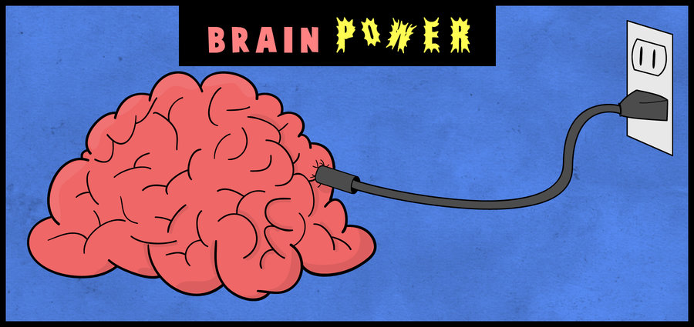

What **TAG** do we write our code in?

____________________________________________________________________________

Each **TAG** must have both a ____________ and a ________ Bracket.

We are working in the program________________

We are saving our code in your_____________ Folder on your Desktop.

Sometimes it is easy to forget kids are at different levels. I included some basic stuff for them. I had a girl cry because she couldn’t figure out saving. I know that GamePlan is love and life, but let us be real for a sec...kids do not read every line of text. This fill in the blank FORCES them to read, and allows them to create a resource for themselves instead of me giving them another hand out with a great wall of text or showing each of them 30000 times.

To **open** a file we **CLICK** the ___________ menu located at the top LEFT of our Brackets Program.

To **save a file for the first time** we click on the ______________ menu on the top LEFT of our screen and click **save as**. We then navigate to our name folder. **We Click This PC**, Then **Desktop**, and finally the folder with our___________as the name. **YOUR folder should be named_______________**(hint: if you cheat off your neighbor this one is going to be wrong.)

After we save for the first time we can either go to file and click save or hit ctrl+_____.

We should make sure to do this often because we do not want to lose any of our precious code!!!

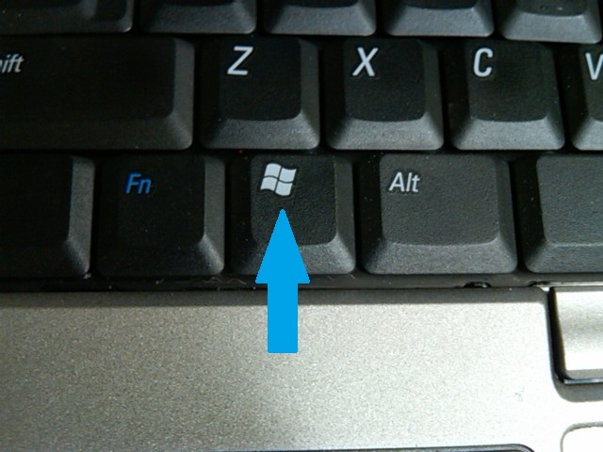

To find Brackets we hit the key AND THEN simply start typing the word “Brackets”.



The program’s ICON should look like the one to the left of this sentence.

The **first tag we need is always that html tag** we see in the above example. Then we must include a **head and body tag** and then **in the head or body tag** we include a **SCRIPT TAG.**

The **head tag** is code for the **top** of the page. The **body tag** is code on the rest of the page below the head tag. We want most of our code in the body tag.

Do not forget to close the tags and put your **;** at the end of your code!

Of course we want a ton of positive feedback for them!

I had them do this sheet in the hallway with each other while I sat and listened to them work through it. Sometimes you can hear their thought process and find out quickly what they are doing right or wrong and address that when we as a group went over the answers. I got to sit and listen for a bit and they got to work and interact with the code. After I had them use the fill in the blank code we made to write the program in brackets so they could prove to me they can at least read and copy code. This is where they found my errors and I addressed them and showed them where the error message shows which line is breaking, and how to debug it. It was a teachable moment.

Here is an epic minecraft castle I found on the internet to keep you motivated!

